**DETAILED STUDY OF UML DIAGRAM**

**QUESTION-**

Study of UML diagrams.

**UML-**

* Unified Modeling Language
* It is a general purpose modelling language used to visualise the designing of a system by use of a UML diagram.
* It is a visual language used to portray the behaviour and structure of a system.
* The Object Management Group (OMG) adopted Unified Modelling Language as a standard in 1997. In 2005, the language was published by the International Organization for Standardization (ISO) and has since been revised and reviewed to keep it up to date.
* UML becomes essential for non-programmers to communicate about essential requirements, functionalities, and processes of the system.

**FEATURES OF UML-**

* UML is used in software engineering to represent, document, and communicate the architecture, design, and behaviour of software systems.
* UML provides a set of graphical notations that enable developers, designers, and stakeholders to understand and collaborate on complex projects.
* The standardisation of UML allows UML diagrams and models to be easily shared, understood and collaborated upon by different organisations, teams, and software tools.
* It offers a variety of diagram types, each serving a specific purpose. Some commonly used UML diagrams include class diagrams, sequence diagrams, use case diagrams, activity diagrams, and state machine diagrams.
* UML promotes the use of abstraction and modularity to enhance the clarity and maintainability of software models.
* Its standardisation, visual representation, abstraction, modularity, comprehensive modelling capabilities, and extensibility make it a versatile tool for modelling and communicating software systems.

**UML DIAGRAMS-**

* A UML diagram is a way to visualise systems and software using Unified Modeling Language (UML).
* A UML diagram simplest code by turning it into a visual representation which is easier to understand.
* It helps keep track of relationships and hierarchies between important lines of code.
* They divide the components and subcomponents essential to build a software
* It helps engineers and non-programmers to avoid getting lost in the complexity of a code.
* UML diagrams are mainly divided into two types and further subdivided to many types.

**TYPES OF UML DIAGRAMS-**

* There are two subcategories of UML diagrams-
  + - Structural Diagrams
    - Behavioural Diagrams
* **Structure diagrams** depict the components that make up a system and the relationship between those components. These diagrams show the static aspects of a system.
* **Behaviour diagrams** represent what happens within a system. They show how all the components interact with each other and with other systems or users.

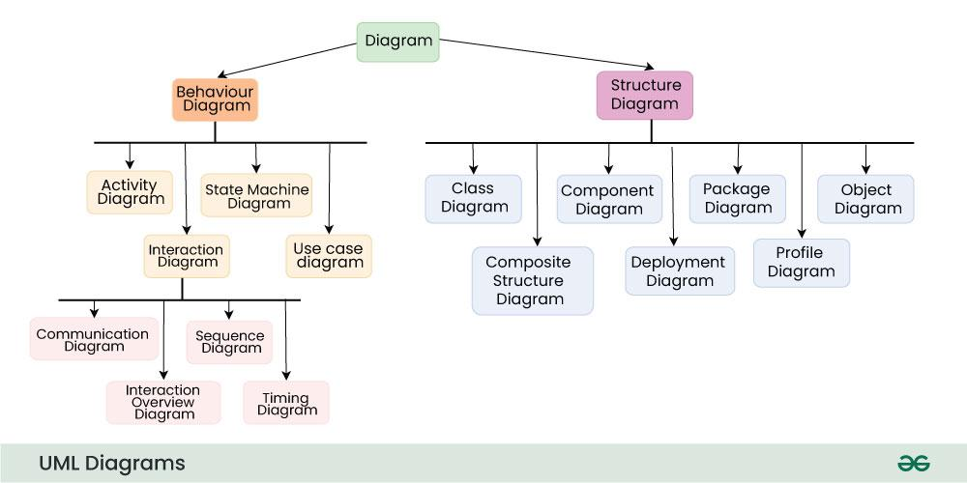

* The above diagram shows the various types of UML diagrams.